Experiment 6.4
Aliasing Effect Demonstration
Aim
Show aliasing when sampling rate is too low.
Program (MATLAB)
% Aliasing Effect Demonstration
clc;
clear;
close all;
% Signal frequency
fm = 10; % Hz
% Sampling frequency (below Nyquist rate)
fs = 15; % Hz
% Continuous-time signal
t = 0:0.001:1;
x = sin(2*pi*fm*t);
% Sampled signal
n = 0:1/fs:1;
xs = sin(2*pi*fm*n);
% Plotting
figure;
subplot(2,1,1);
plot(t,x,'LineWidth',2);
grid on;
title('Original Continuous-Time Signal');

xlabel('Time (s)');
ylabel('Amplitude');
subplot(2,1,2);
stem(n,xs,'filled');
grid on;
title('Aliased Sampled Signal');
xlabel('Time (s)');
ylabel('Amplitude');
Output Generated Graph
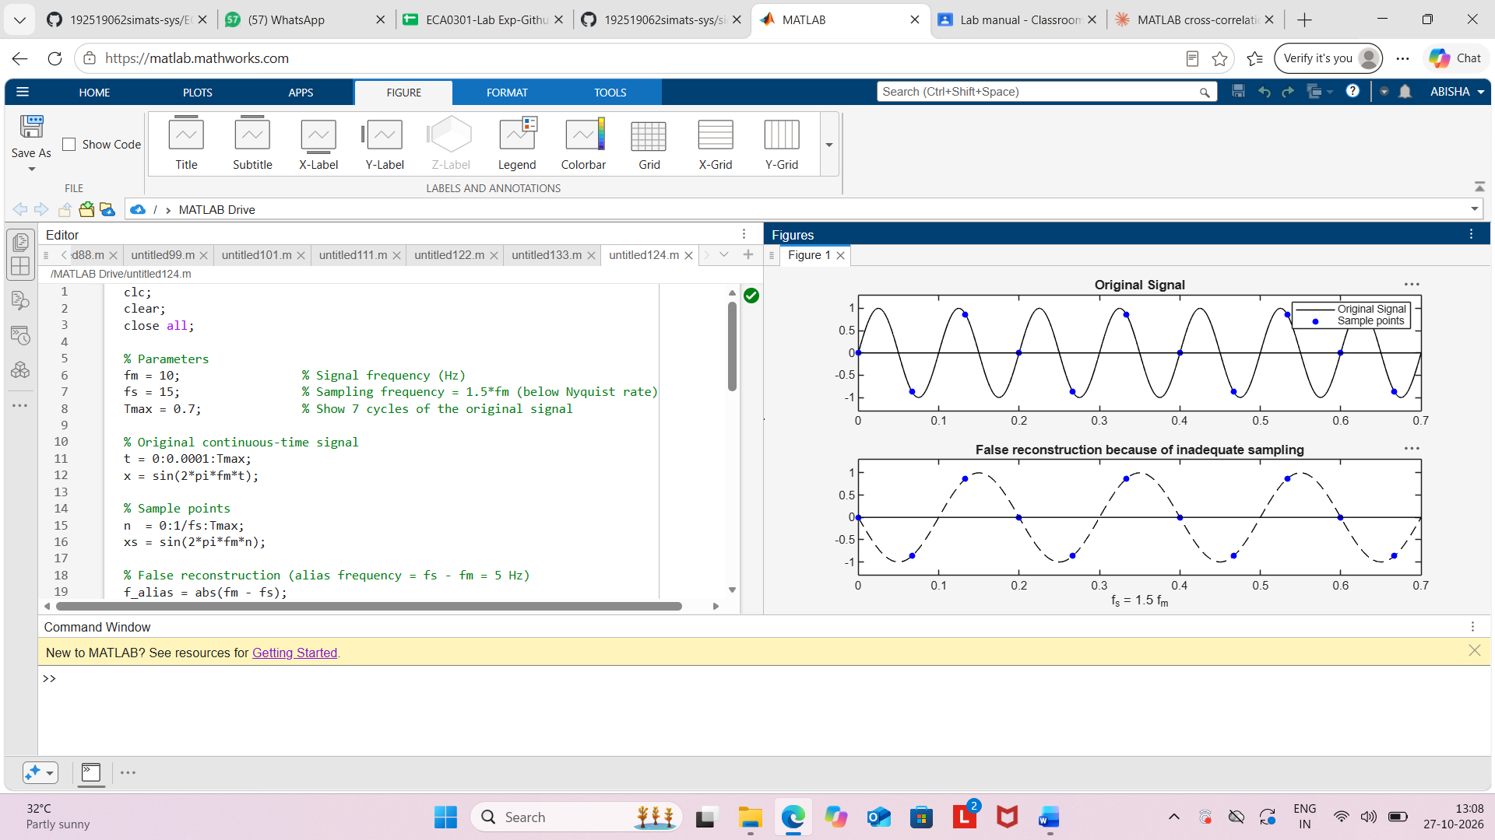
Result.
The aliasing effect was demonstrated successfully using MATLAB. A 10 Hz sinusoidal signal
sampled at 15 Hz (below the Nyquist rate of 20 Hz) appeared as a lower-frequency 5 Hz
signal, confirming the occurrence of aliasing due to undersampling.

